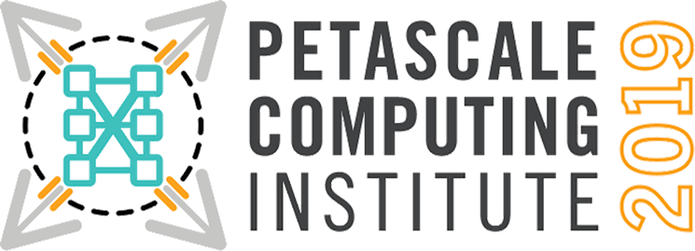

Registration is now open for the Petascale Computing Institute on August 19 – 23, 2019. The Institute is free and open to everyone. For more information about agenda, locations, and how to register, visit the website at:

https://bluewaters.ncsa.illinois.edu/petascale-computing-2019
Keynote
Man vs. Machine:
The Challenge of Engineering Programs for HPC

The first era of scientific computing was defined by Seymour Cray computers hosting single memory FORTRAN programs. In 1993, the first multicomputer with a thousand of independent and interconnected computers outperformed mono-memory supercomputers at 60 gigaflops. In 2019, supercomputers have millions of processing elements and operate at hundreds of petaflops. This performance gain of over two million changes not only the nature and scale of the science being simulated or analyzed, but also algorithms, design, and maintenance of the programs.
Gordon Bell
HPC Pioneer

ABOUT THE INSTITUTE

The goal of the institute is to teach the participants to scale their computational codes to leadership-class computing systems. The content is targeted for individuals conducting research and scholarship in all disciplines, including graduate and undergraduate students, postdocs, faculty, researchers, scholars, educators, and practitioners in academia, industry and government agencies. The institute will be beneficial to research teams who are preparing to scale their codes to petascale-class resources, people who are working on parallel codes, or have a need to scale up computational codes and/or data analysis programs. Individuals who are current or pending users of large-scale HPC systems will benefit the most from this institute.

HOW TO PARTICIPATE

Participants may attend the Institute at one of the host sites. At these sites, participants will be able to verbally ask questions of the presenters through two-way video conferencing facilities. Participants will receive training accounts on the available HPC systems. Staff will be available at each site to assist during hands-on sessions. Seating at each site is limited, and registration will be handled on a first-come-first-served basis.

ORGANIZING PARTNERS

Argonne National Laboratory, the Blue Waters project at NCSA, the National Energy Research Scientific Computing Center, Oak Ridge Leadership Computing Facility, Pittsburgh Supercomputing Center, SciNet at the University of Toronto, and the Texas Advanced Computing Center.

